

Planning Critical Thinking :

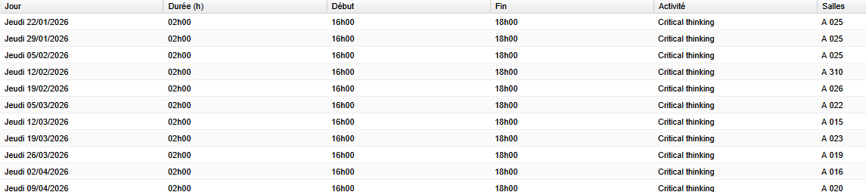

Examen :

